IP Infiltration Screenshots from the Practical

IP being used:

* 172.17.4.55

Software & Tools being used:

* Personal Python Script
* OpenVAS
* NMap
* Hashcat
* Burp Suite
* SQLMap
* Metasploit

Ports Infiltrated:

* Port 21 – FTP
* Port 22 – SSH
* Port 80 – HTTP
* Port 111 - RPCBIND
* Port 2049 - NFS

**Reconnaissance:**

Personal PYTHON Script to scan ports:

^code

OpenVAS to discover all vulnerabilities with the IP:

Using Nmap:

**Infiltration of FTP / 21:**

**Infiltration of NFS / Port 2049:**

Using Hashcat to decrypt the password:



**Infiltration of SSH / Port 22:**

**Infiltration of HTTP / Port 80:**

Using Burp Suite to create a custom GET REQUEST file:

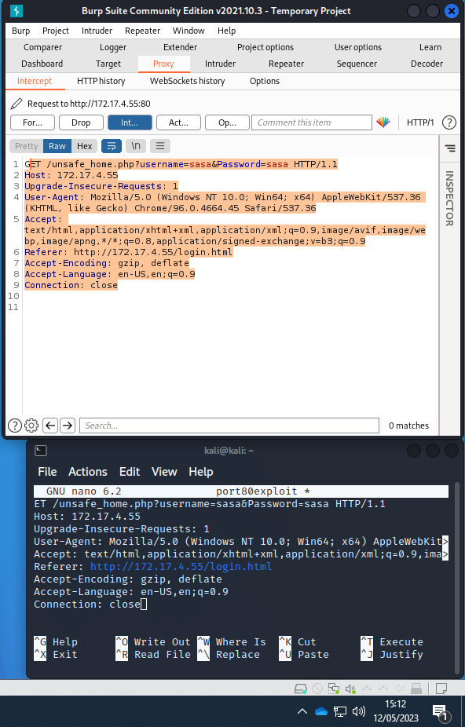

Using SQLmap to utilise the custom GET REQUEST file to create a custom payload to bypass the login page of the website:

**Infiltration of RPCBIND / Port 111:**

Using Metasploit rpcbomb to DoS port 111:

